# Financial Analysis using Tableau

Click [www.sudeepanalytics.com](http://www.sudeepanalytics.com) to refer all the details

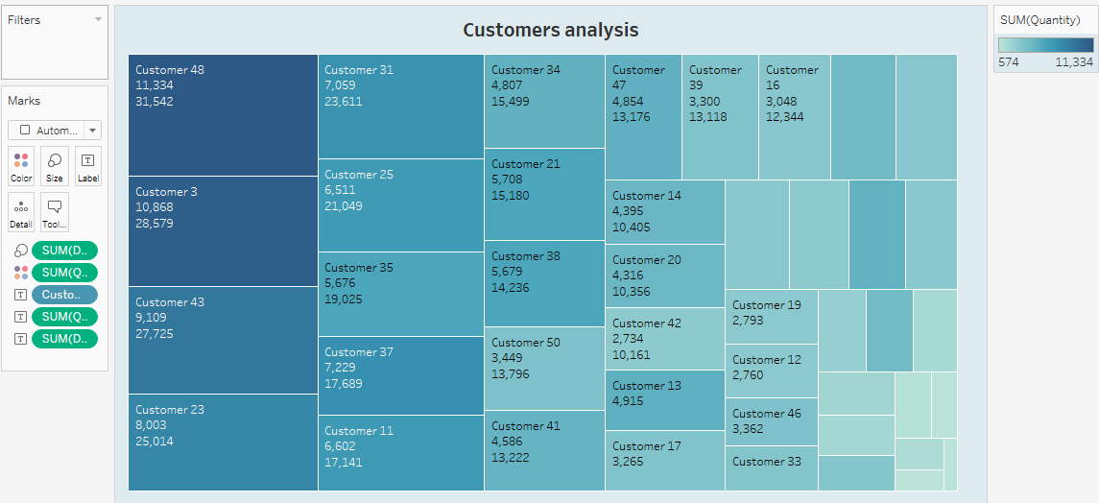

Worked on the analysis related to a Pen company. Have shown analysis on  Customer,Product and Revenue.

Data have been prepared using the Sales invoice details.Data cleaning is completed like duplicates, spelling mistakes,NA values have been removed.Data analysis has been done in Tableau after importing the file.

Customer Analysis:

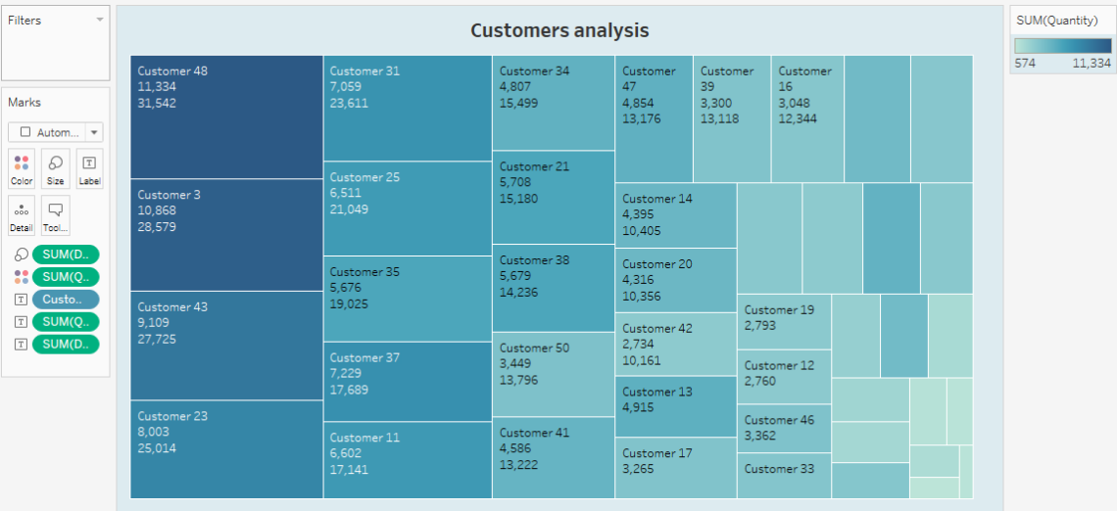

Customer 48 is giving highest Sales value followed by customer 3.Sales quantity is also high as well as revenue is high as seen from the below analysis.

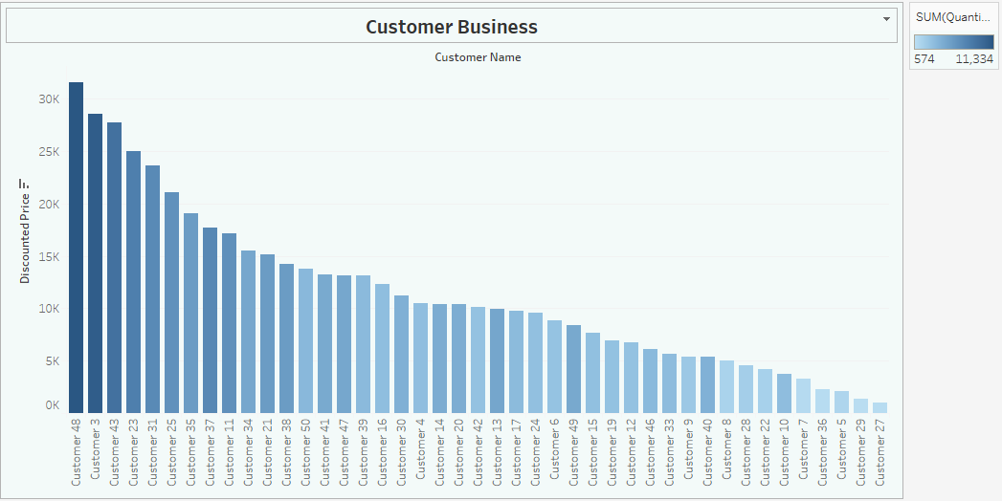

Customer 48,3 have given us high business and have to retain them. we have check with low business customer like customer 5,29,27 and would try to improve business with them after ascertaining the reason.

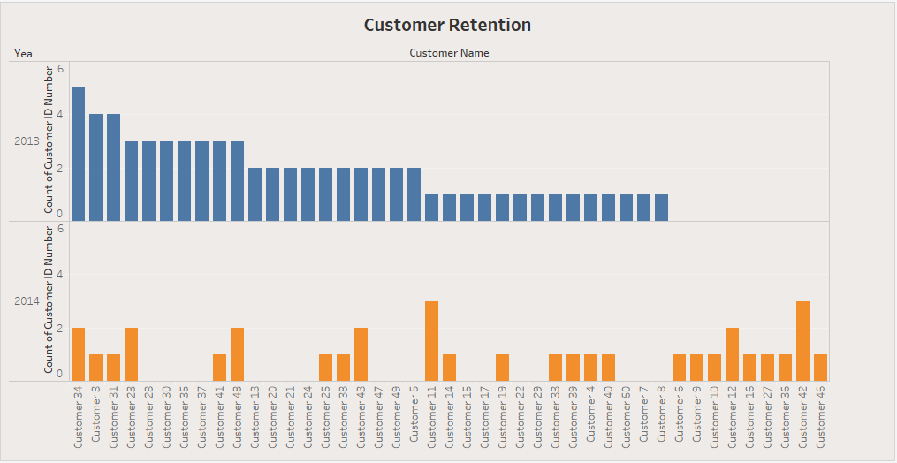

Customer Retention : When we compare customer orders with last year, we can see many customers have not started business for 2014. We have to follow up and check with them. We can see there are new customers acquired for 2014 which shows the customer growth is good for the company.

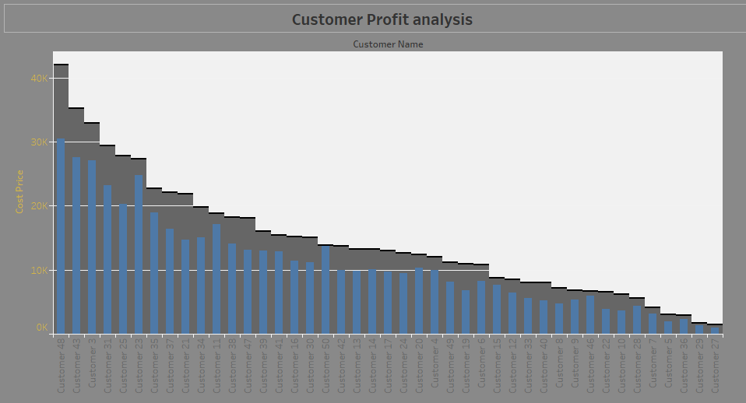

Customer Profit analysis: we can see customer 48, 43 is having high revenue as well as profit margin is high for them. We may have check for customer 50, 23 who are giving us lessor profit margin. Ascertain the reason for lower profit margin.

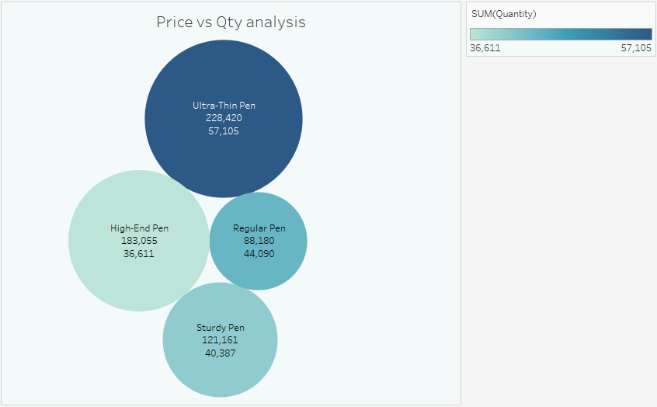

Product analysis: We can see Ultra Thin Pens have high sales as well as qty amoung all the products. High-End pen has 2nd highest sale value but the quantity sold is less compared to other products. Marketing team should look into this to increase the quantity of sale for High-end pen.

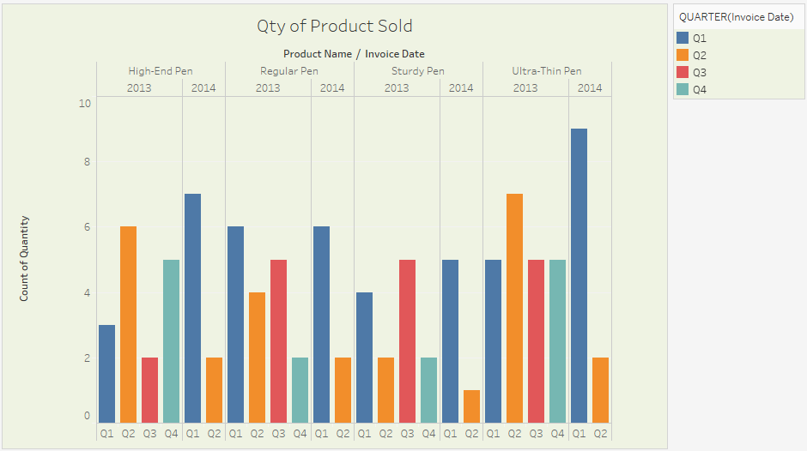

Timelines: Sales for high end pen was relatively more compared to sales of Q1 2014. Sales has reduce for the same in Q2. Sales for Ultra-thin pen has almost doubled for Q1 2014 when compared to Q1 2013.Ultra-Thin pens have a stable sales throughout the year and with fluctuation in the sales for Regular pens.

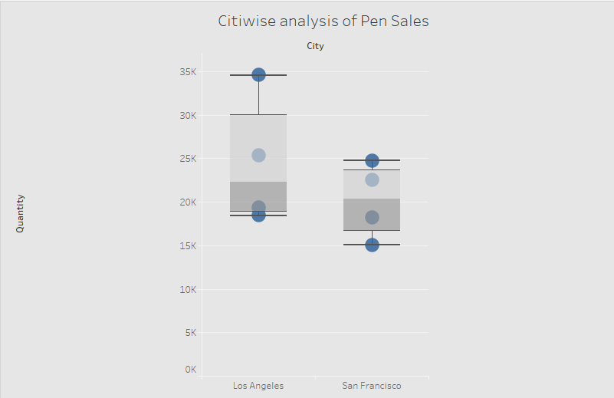

Box Plots-The average sales in both the cities like between 20k to 22k.For Los Angeles Ulter Thin pens having highest value at 35k lowest being highendpens at 18K quantity.For San-Franc city, the pen sales within the 25th to 75th percentile while for Los Angeles city the 25th to 75th percentile range is more with a very high range for 95th percentile.

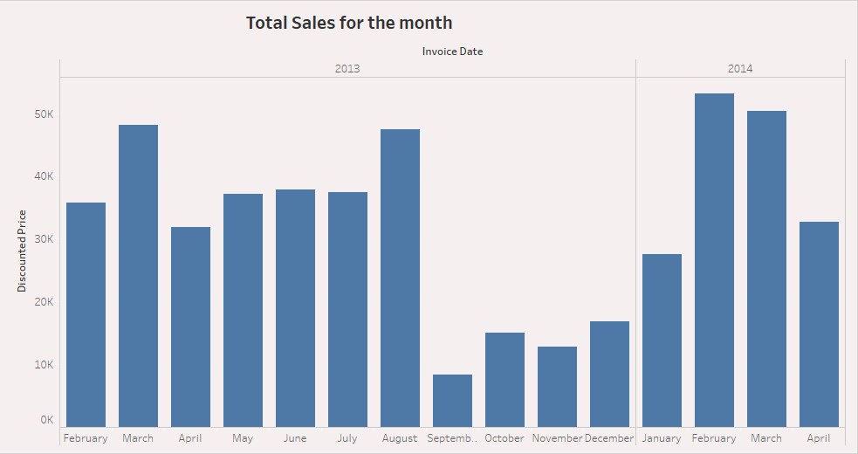

Sales Forecast:Sales are high during Feb, March and low during the end of year from Sep to Dec.Marketing team may have to check the reason for this decline in sales during the last few months of the year.

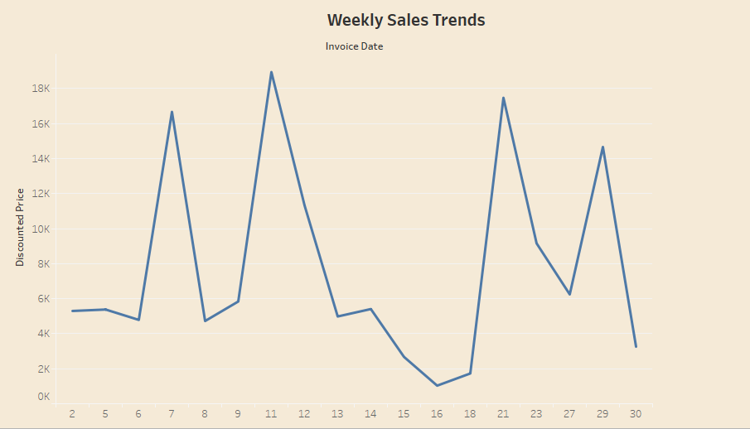

Sales Trends: Sales usually dips during the middle of the month and are high during the last week and first few weeks of the month. Additional incentives can be given to sales team to have a stable sales through out the month.

[Edit"Financial Analysis using Tableau"](https://wordpress.com/post/sudeepanalytics.com/205)

**ROFILE SUMMARY**

* A competent professional with nearly 15 years of experience in Financial Analytics, General Accounting, Internal Control, Accounts Reconciliation Process and Transition Management
* Competent in analysing business requirements, assessing complex financial data to provide customized data solutions towards the accomplishment of corporate goals
* Strong People Management skills with proven capability in coaching, mentoring, inspiring and nourishing diverse teams

**ACADEMIC CREDENTIALS**

* **PG Diploma in Data Analytics** I IIIT-Bangalore & UpGrad I **CGPA** 2.85 / 4 Since Mar 2017

*A comprehensive 11-month program taught by Industry experts and IIITB faculty; 7 case studies & projects; 400+ hours of academic learning & 30+ hours of industry mentoring*

* **CIMA Adv Dip** in 2013from CIMA-UK (www.cimaglobal.com)
* **MBA** (Finance), Annamalai University, 2008
* **B.Com** (Accountancy, Income Tax), Karnataka University, 1997

**KEY PROJECTS**

* **Car Price Prediction**: Predicted the independent variable significant to the price of car. More than 50 independent variables were checked using Linear Regression and final 8 variables were finalised after removing insignificant variables.
* **Analysis of Pen Company:** Customer, Product and Revenue analysis was completed using Tableau. Customer with highest business, high & low profitable customers, product with maximum & low sales were identified, sales volume analysis over the period was done.
* **HR Analytics :** Recommended ways to reduce attrition using Predictive modelling like Logistic Regression, KS Statices, Gainchart was able identity 80% employee likely to churn. Responsible Factors like age, experience, Job satisfaction, worklife bal etc were identified.

**WORK EXPERIENCE**

Assistant Operation Manager, Accenture India, Bangalore July 2005 to June 2017

* Completed assigned accounts reconciliation 2 days before the due dates every month for Account Owner to review.
* Reduced more than 60% errors in Account reconciliation process by creating control checklist
* Designed and Implemented Weekly Dashboard to monitor the pending telecom invoices.
* Coordinated with Opex Lead to drive Opex across ATR consisting of 14 Teams
* As a part of Internal Control process, more than 500 Internal Control process review was created and tested for new as well as existing process.
* As a part of Business Continuity Process Project, coordinated across multiple locations (Bangalore, Manila, Buenos Aires) and provided application access to test 410 critical users to perform the critical activities in case of any Business contingency events.
* Took up a critical project assignment to successfully complete KT on Fixed Asset & Inventory accounting process from Wipro India and complete the reverse KT to Accenture Noida Team.
* Recognized as subject matter expert within scope of Fixed Assets responsibility and implemented Winshuttle tool for automation as a part of Fixed Asset Team Lead role.

**KEY SKILLS**

• **Machine Learning** Modelling Techniques • **Analytics Languages**: R (Intermediate), Python & SAS (Introductory)

• **Visualization tools**: Tableau, R • **MS Excel :** Advanced level

• **Hypothesis Testing** • **Databases:** MySQL

* **Statistics** & Exploratory Data Analysis • **ERP: SAP, Oracle**

**ACCOLADES**

* Travelled to Accenture-Buenos Aires in July 2013 and helped set up Internal Control(QCD) process
* Received appreciation from Client for successfully completed the Transition one from Brazil and other in Accenture-Noida.
* Received appreciation from client for analysing more than 1000 open line items in account recons and reduced to less than 100.
* Received Front Runner award from Accenture for successfully completing Internal Control(QCD)process